Web Application Using Node-Red

Project Name: Smart Farmer - IoT Enabled Smart Farming

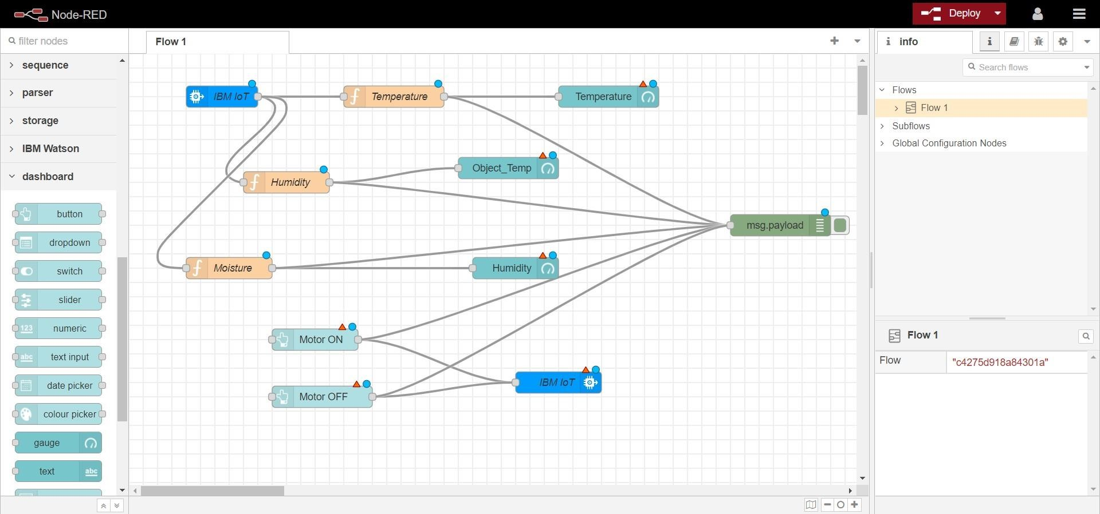Team ID: PNT2022TMID24187

Flow 1

Flow 2:

